**EV BMS With Charge Monitor and Fire Protection**

Electric vehicles surely are the future of transportation, but ev technology has not been fully developed with respect to efficiency and safety as of 2022. We come across electric vehicle battery fire and similar incidents as the EV market expands.

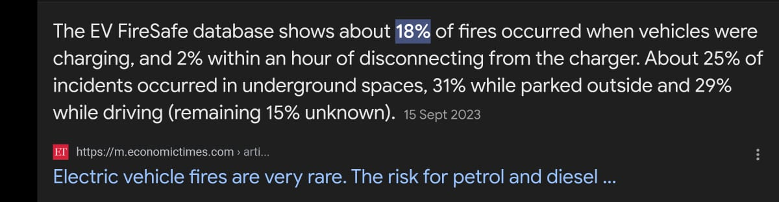

Most electric vehicle fire incidents occur due to battery blast or fire. So here we attempt to solve the problem by using some sensors and battery pack based system powered by an STM32 controller. The system is designed to protect batteries from various parameters that may incite a fire.

The system is designed to constantly monitor battery voltage current temperature and instantly cut off the input or output from battery as soon as any unusual behavior is detected.

This System provides the following advantages:

* Battery Status Monitoring and Display
* Charging of Battery as per required input parameters
* Temperature monitoring with auto cutoff

The system makes use of a li ion Battery, Battery charging and monitor system, Push Buttons, LCD Display, current sensor, voltage sensor, temperature sensor to develop this system. The system monitors as well as protects an EV battery at all times.

We here develop the system as per a 3S li ion battery. The system we design will not only monitor the battery and charge it safely but also protect it to avoid accidents from occurring. The system when turned on uses its charging and monitoring circuitry that allows user to safety charge the 3S battery.

While charging the voltage sensor is used to check voltage and limit the flow of current too to the battery using charging circuitry. The LCD display also displays the current voltage level of battery. As soon as the battery is fully charged, the system cuts off the supply and displays Battery fully charged on LCD Display.

When connected to a load the current sensor keeps track of current drawn from battery and displays the parameter on LCD Display. The temperature sensor is used to monitor temperature of battery while charging as well as discharging.

If the battery temperature is observed to deviate from standard values, the system automatically cuts off input as well as output supply and displays the temperature as well as a buzzer alert on the LCD display. Thus the system allows for a smart and efficient battery charging as well as protection system

**Components**

* STM32 Controller
* Temperature Sensor
* Voltage Sensor
* Current Sensor
* LCD Display
* Li ion Battery
* Regulatory Circuitry
* Switches
* LED’s
* PCB Board
* Resistors
* Capacitors
* Transistors
* Cables and Connectors
* Screws and Bolts

**Block Diagram**

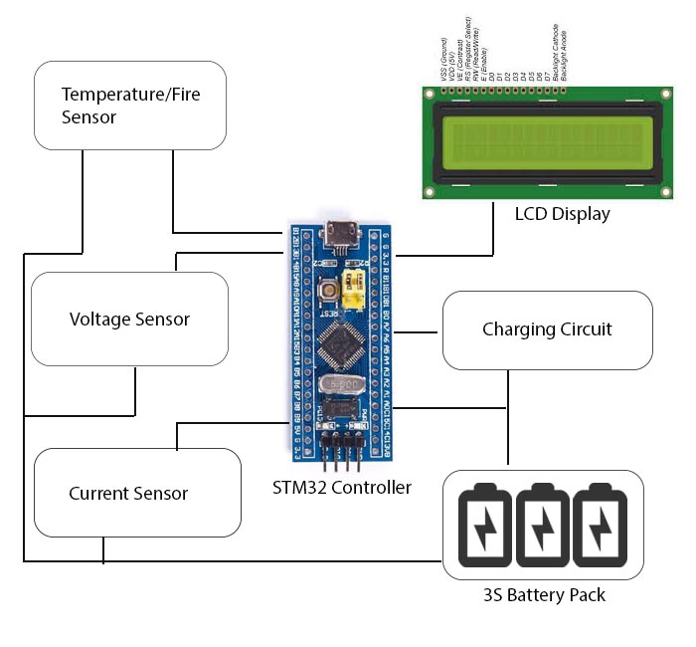

**Reference**

* <https://www.sciencedirect.com/science/article/abs/pii/S095965262100264X>
* . [https://www.researchgate.net/profile/Andrzej-Lebkowski/publication/316171277_Tem perature_Overcharge_and_Short-Circuit_Studies_of_Batteries_used_in_Electric_Ve hicles/links/59035e750f7e9bc0d58d7050/Temperature-Overcharge-and-Short-Circuit -Studies-of-Batteries-used-in-Electric-Vehicles.pdf](https://www.researchgate.net/profile/Andrzej-Lebkowski/publication/316171277_Tem%20perature_Overcharge_and_Short-Circuit_Studies_of_Batteries_used_in_Electric_Ve%20hicles/links/59035e750f7e9bc0d58d7050/Temperature-Overcharge-and-Short-Circuit%20-Studies-of-Batteries-used-in-Electric-Vehicles.pdf)
* <https://www.sciencedirect.com/science/article/pii/S2352152X21004734>
* <https://ijcaonline.com/volume28/number6/pxc3874717.pdf>
* <https://www.hindawi.com/journals/afs/2012/687652/>
* <https://www.mdpi.com/2032-6653/14/4/101>
* <https://ieeexplore.ieee.org/abstract/document/6176637/>
* <https://www.mdpi.com/1996-1073/4/11/1840>